**Frontend Development with React.js**

**Project Documentation**

**Introduction**

Project Title: InsightStream : Navigate the News Landscape

Team Members: Roshan Sabeeha K(Team leader) - Demo video

Roshini S - Documentation

Pooja Sri S - Error checking and testing the Program

Raja Lakshmi E - Program Execution and Running

Deepika M - Collecting of API key

**Project Overview**

Purpose: InsightStream is a news application designed to help users navigate the complex and fast-changing news landscape. It aggregates news from multiple reliable sources, categorizes articles by topics, and provides personalized recommendations to ensure users stay informed with relevant updates.

Features of InsightStream:

News from API Sources: Access a vast library of global news spanning various categories and interests, ensuring a well-rounded coverage of current affairs.

Visual News Exploration: Discover breaking stories and explore different news categories through curated image galleries, enhancing the visual appeal of news discovery.

Intuitive Design: Navigate the application seamlessly with a clean, modern interface designed for optimal user experience and clarity in information presentation.

Advanced Search Feature: Easily access news articles on specific topics through a powerful search feature, providing users with tailored news content based on their interests.

**Architecture**

Component Structure: The app consists of major React components including Header, News Feed, Category Selector, Search Bar, Article Card, Subscription. These components interact to provide a smooth browsing experience.

State Management: Context API is used for global state management, ensuring that selected categories, user preferences, and bookmarks are available across all components.

Routing: React Router is used to handle navigation between the home page, category pages, and bookmarks page.

Hero components : Home page, category page which displays news based on categories.

Popular categories: Displays trending news updates with view more options.

News letter: Subscription with email id.

Category /search result page: Searches for the categories entered.

Redirected page: redirect to the home page.

**Setup Instructions**

Prerequisites: Node.js, npm, Git

Installation:   
1. Clone the repository from GitHub  
2. Run 'npm install' to install dependencies  
3. Configure environment variables for API keys  
4. Run 'npm start' to launch the application

**Folder Structure**

Client: The React application is organized into folders such as components (UI components), pages (News Feed, Bookmarks), assets (images, styles), and utils (helper functions).  
  
Utilities: Custom hooks (e.g., useFetchNews), helper functions for API requests, and utilities for data formatting are included.

**Running the Application**

To start the frontend server locally, run the following command inside the client directory:  
npm start

**Component Documentation**

Key Components:  
- Header: Navigation bar with search and category links  
- News Feed: Displays articles from selected categories  
- Search Bar: To searches a News categories

-Category selector: Displays the list of News based on category

Reusable Components: Buttons, Modals, and Input fields are implemented as reusable components for consistency.

**State Management**

Global State: Managed using Context API to handle user preferences, SearchBar and selected categories.  
Local State: Handled within components for UI-specific states like modals, dropdowns, and loading indicators.

**User Interface**

The UI is designed to be clean and intuitive, with a responsive design that adapts to mobile and desktop devices. Screenshots or demo links can be added here to showcase the layout.

**Styling**

CSS Frameworks/Libraries: Tailwind CSS is used for styling along with custom CSS modules for component-specific styles.

**Testing**

Testing Strategy: Unit tests are written for components using Jest and React Testing Library. Integration tests ensure smooth data fetching and rendering.  
Code Coverage: Jest coverage reports ensure adequate test coverage for critical features.

**Screenshots or Demo**

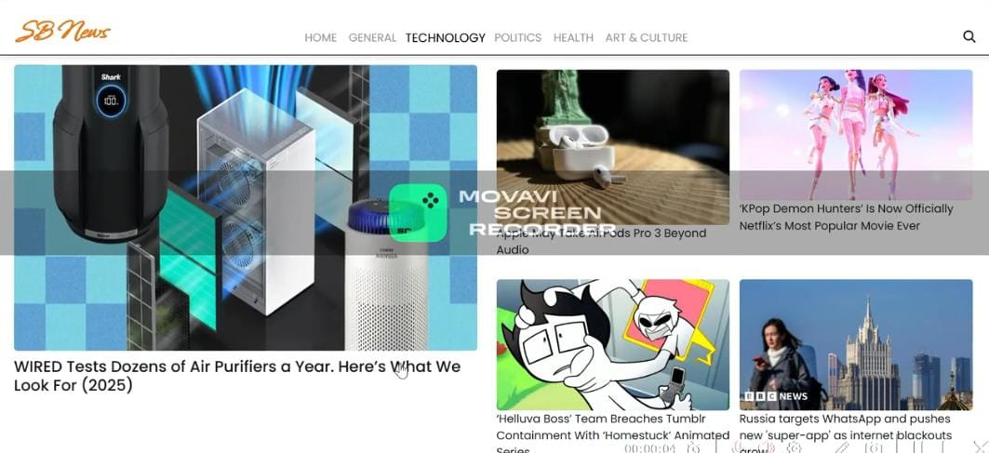

https://drive.google.com/file/d/1MZ-dTQEneIJa_AYPM5RfFZoCQc3Eel4t/view?usp=drive_link

**Known Issues**

Currently, some articles may load with delays due to API rate limits. Occasional layout misalignments occur on smaller devices.

**Future Enhancements**

- AI-based summarization of news articles  
- Offline reading mode  
- More personalized recommendations based on user reading habits  
- Push notifications for breaking news